**Summer Aleks access**

You will have access to Aleks this summer. After June 30th, you will find your Aleks program under “Archived” classes.

After launching the McGraw Hill app on ClassLink

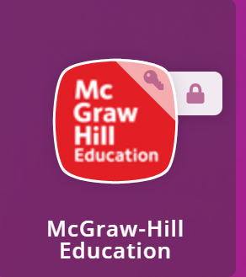

Click on the “Archived” tab to find your Aleks icon.  
  
